Khiew Jian Bin

Group 3B

Just a Simple AR game

CZ 4001 Virtual and Augmented Reality

AR Assignment Report

Contents

Introduction – What is AR 2

How is it different from VR? 2

Unity AR Project Objective 2

Platform 2

Assets 2

Main Idea 2

Setup Process 3

Character Implementation 3

Characters Mechanics 5

Spawning Characters 5

Character Actions 5

Sound and UI 6

Problems 6

Future plans 6

Android Build testing – Demo Video 7

Hyperlinks 7

# 

# Introduction – What is AR

Augmented Reality (AR) is a term used to describe having a view of reality and the environment being altered or “Augmented” by computer-generated information. Computer generated information can be in the form of visual (sight), audio (sound) , haptic(touch), [olfactory](https://en.wikipedia.org/wiki/Olfactory) (sound) or gustatory (taste).

## How is it different from VR?

While Virtual Reality(VR) is about having a 100% computer generated virtual environment for people to experience simulated realistic or unrealistic environment, object interaction, physics such as gravity. AR is about using the real world and its environment and changing it and enhancing with a computer.

The experience of VR can be very immersive with realistic 3D sound and touch, however at the current technology, using VR will face certain issues such as motion sickness by disorientation of the vestibular system which affects the sense of balance and spatial orientation.

On the other hand, AR does not have issues like motion sickness as it simply augments the existing real-world view but is unable to have the full immersive feel.

# Unity AR Project Objective

This main goal for this report is to explain the process in making a simple working AR project using Unity 3D engine as well as the inspiration, techniques and mechanics used.

## Platform

The main target platform is the Android devices. This unity AR Project will be tested on PC and android.

# Assets

Below list the assets used in creating the AR project

|  |  |  |
| --- | --- | --- |
| ID | Asset Name | Source |
| 1 | AR Vuforia | AR Template |
| 2 | Fighter Image | Photoshop |
| 3 | Enemy Image | Photoshop |
| 4 | Weapon Image | Photoshop |
| 5 | Dissolve Shader | https://github.com/kwnetzwelt/unity3d-dissolve-shader |
| 6 | Spider | https://free3d.com/ |
| 7 | Black Dragon | https://free3d.com/ |
| 8 | Fly sound | SoundBible.com |
| 9 | Eat sound | SoundBible.com |
| 10 | Dragon Roar sound | SoundBible.com |

# Main Idea

The main idea of the AR project is to use AR Vuforia along with unity to create a natural feature detection on real world flat pictures. There will be two types of images

1. Fighter
2. Enemy

Fighter is an image used to spawn a fighter unit that can attack and destroy enemy unit,

Enemy is an image used to spawn an enemy unit that can only run away.

Fighter unit will be using the Black Dragon model

Enemy unit will be using the Spider model

This is a simple project that uses the AR Vuforia feature detection to create virtual characters that can interact with other virtual characters.

# Setup Process

The AR Vuforia unity template provides all the tools needed to do AR natural feature detection. I used the template as the starting point and created and uploaded the **fighter** and **enemy** images to be used for feature detection to the Vuforia developer portal

|  |  |
| --- | --- |
| Enemy image 512x512 | Fighter image 512x512 |

The Vuforia developer portal allow us to upload our AR images and process the features of the images for us instead of writing our own feature detection algorithm function.

|  |  |
| --- | --- |
| Features of Enemy image | Features of Fighter image |

After which, I downloaded the processed images as a complied database for Unity and import it into the project. From here onwards, Vuforia already allow us to have a quick easy setup to have the enemy and fighter image place in the Unity Scene and any objects and models place as a child will be rendered based on using a camera and the view of the features detected form a real hardcopy enemy and fighter image.

After obtaining the Spider and Dragon royalty free rigged and animated models online, now all is left is the character mechanics implementation.

# Character Implementation

There are only two characters, the spider(enemy) and the dragon(fighter). Both characters are rigged and animated. In order to show some kind of interaction of the characters, I set them up to play certain animation depending on the state of the characters.

If either the **Spider(enemy)** or the **Dragon(fighter)** is spawned alone in the camera view,

they will play its own Idle animation

|  |  |
| --- | --- |
| Spider Idle Animation | Dragon Idle Animation |

If both the **Spider** and the **Dragon** is spawned,

the **Spider** will try to run away and play the **back walk** animation,

the **Dragon** will play a **flying** animation and fly up and proceed to **attack** the **spider**

|  |  |
| --- | --- |
| Spider back walk animation | Dragon flying animation |

If the Dragon manage to attack the spider, the spider will be killed and plays the death animation.

In addition, after the death animation, the spider will also dissolve out of the world.

|  |
| --- |
| Spider Death Animation + Dissolve Shader Out Animation |

In addition to the spider model **dissolving out** from the world.

Both Dragon and Spider will **dissolve into** the world, as the camera detects the image features and spawns the respective characters

|  |
| --- |
|  |

# Characters Mechanics

This section will explain the Spider and Dragon characters mechanics in the AR project.

# Spawning Characters

As mention previously, Vuforia provides an easy setup to allow us to have the spider, and dragon spawn on top of the image detected using natural feature detection by the camera.

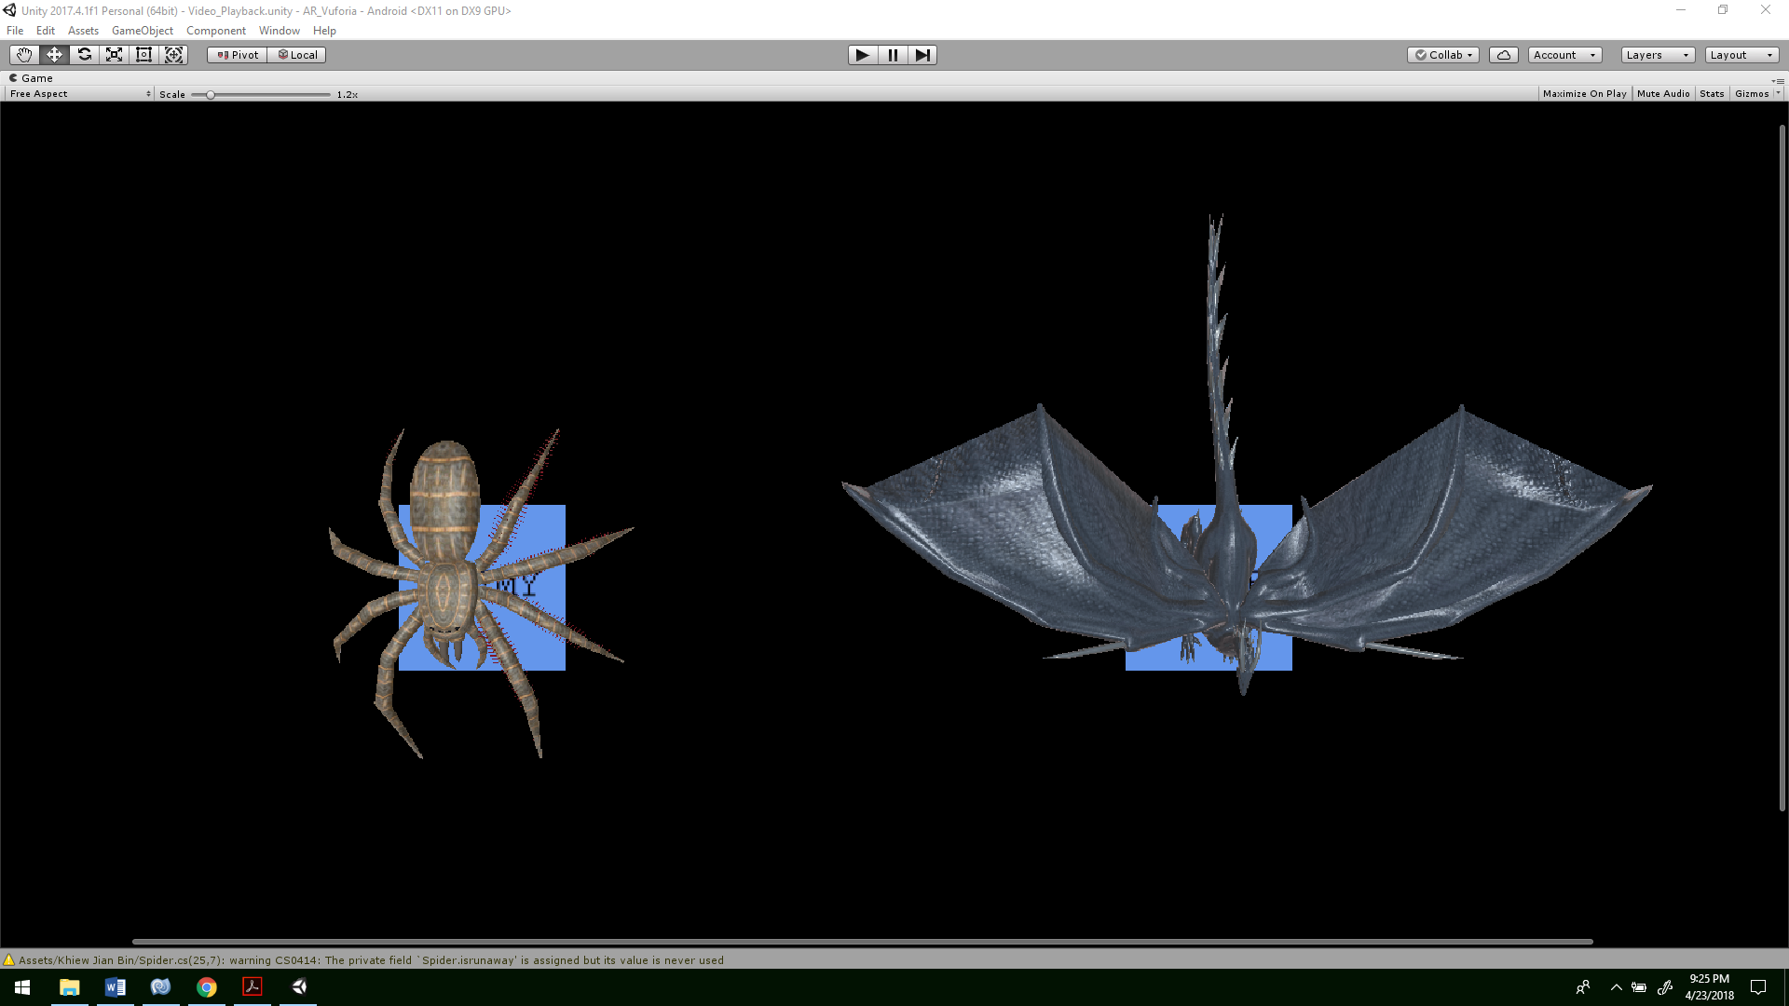

Spider character model spawns on top of “**Enemy**” Image

Dragon character model spawns on top of “**Fighter**” Image

# Character Actions

The spider model only animates and does not move.

But the dragon can move slightly upwards in the air when playing flying animation and **rotating slowly** to face the spider, this is then followed by the dragon **looking towards** the spider and **charging forward** towards it to attack it. After the spider is attacked and dies, the dragon resets back to original position

# Sound and UI

To make the character feel more alive, I included a **dragon roar sound** to be played when the dragon is **Idle**, a **dragon flying sound** to be played when the dragon is **flying**, a dragon eat sound to be played when the dragon attacks and kills the spider, and eats the spider.



[Embbeded sound into Word doc: **Double click** to play sound]

Also to keep track of how many spiders the dragon has ate since the start of the application, I include a 2d UI text to indicate how many spiders the dragon has eaten.

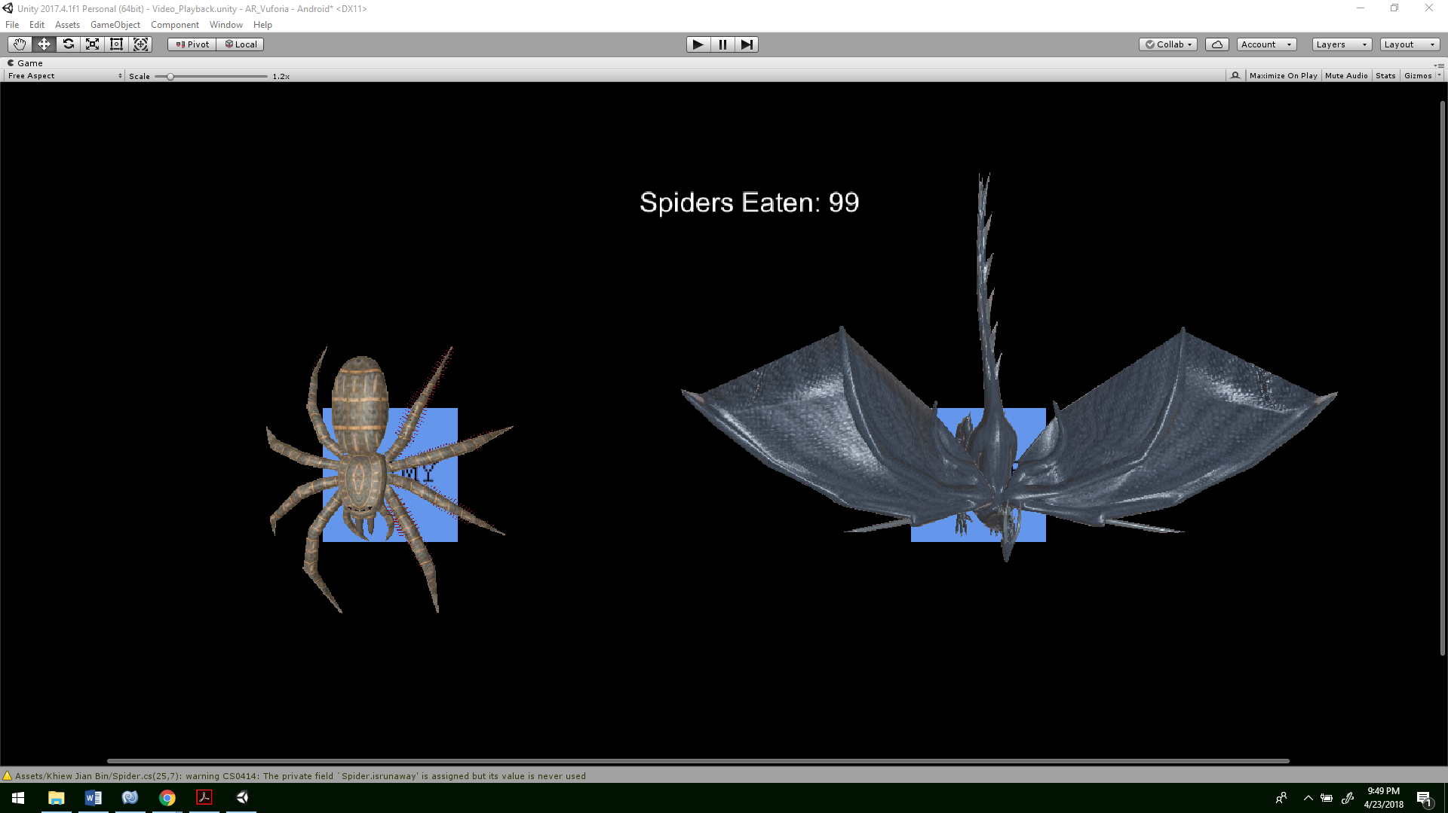

Spiders Eaten UI text

# Problems

I am unable to have the camera detect the feature of images far away and spread out apart from each other. I suspect this is because of the resolution of the image as well as the possibly the testing android device (Samsung galaxy core) has a poor camera resolution.

As a result, it is hard to see the flying and attacking motion of the dragon.

# Future plans

* Add multiple spiders and dragon tracking
* A new image that spawns a gun that can rotated to shoots bullet to kill the spiders and dragon.
* A new image that spawns a ball that the user can click/tap and drag it around and fling it to other characters
* Find a solution of unable to track image far away from camera
* Include a mix of VR and AR

# Android Build testing – Demo Video

This project supports tracking one Dragon(fighter) and one spider(enemy) at the same time.

This project is tested on only Samsung galaxy core.

The demo video of the test is given in a folder “DemoVid”

# Hyperlinks

[Readme.txt](DemoVid/ReadMe.txt)

1.DemoVid - this is the main vid show casing the spider(enemy) and fighter(dragon) spawn, animation and interaction

2.DemoSpider - this is a vid showing the spawning of the spider

3.DemoDragon - this is a vid showing the spawning of the dragon

4.DemoExtra - this is an extra vid showing testing footages

Note: I am unable to record the sound, only video

[DemoVid\DemoVid.mp4](DemoVid/DemoVid.mp4)

DemoVid\DemoSpider.mp4

DemoVid\DemoDragon.mp4

[DemoVid\DemoExtra.mp4](DemoVid/DemoExtra.mp4)